Jacob Ryan Zayak & Savion Jackson

CPT 212 – 001  Spring 2018

Airplane Reservation System (ARS) Documentation

Contents

Flowchart showing structure of the application: 2

Pseudocode: 2

Forms 4

Program Requirements and Testing 5

Main Functionality: 5

Improvements: 5

Credit 6

# Flowchart showing structure of the application:

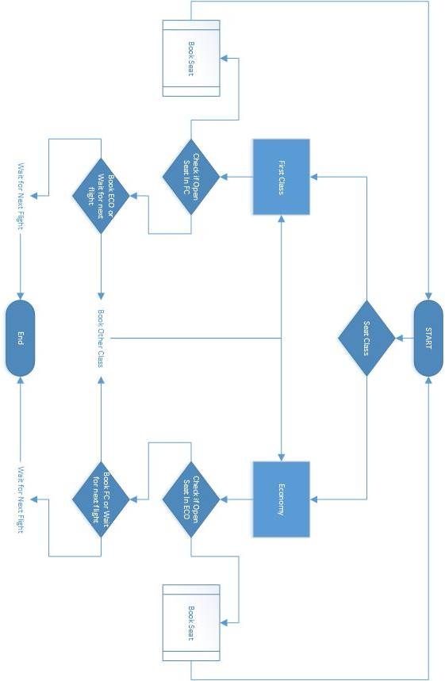

# Pseudocode:

*Declare array to hold whether seat is booked or not*

*Declare Boolean variable to hold if FirstClass is full*

*Declare Boolean variable to hold if Economy is full*

*Create picturebox control array to hold seat icons*

*Declare Boolean variable to break out of while loop once a seat is filled.*

*Declare a counter*

*While the seat is empty, if FirstClass is selected and we are looking at seats 1-5*

*If the seat is empty, then make seats(i) = true, change the color of the*

*picturebox*

*and exit loop*

*Create while loop for "emptySeat"*

*Create If Then statement that -If first class and economy is full, then move to Economy*

*Declare newFlight*

*Set newFlight = Message Box*

*Create if Else to determine the result of DialogResults*

*While the seat is empty, if Economy is selected and we are looking at seats 6-10*

*If the seat is empty, then make seats(i) = true, change the color of the picture box, exit loop*

*If counter is below 5 and Economy is selected then make counter start at 5*

*Else add one to counter and re-loop.*

*If first class and economy is full, then move to Economy*

*Reset the form for next flight –*

*Else newFlight = DialogResult.Yes*

*Close Form*

*DLL for capturing screen and printing*

*Get the screenshot*

*Capture boarding pass panel*

*Sets print area for print button event*

*Print the Boarding Pass*

# Forms

Main form:   
This form is the main, containing menu bar, seat indicators, First Class and Economy Class radio buttons, and a “Book Seat” button. The user selects either First Class or Economy Class and clicks the “Book Seat” button to display the boarding pass.  
After booking a flight, the user can bring a boarding pass back up by clicking on the desired seat.  
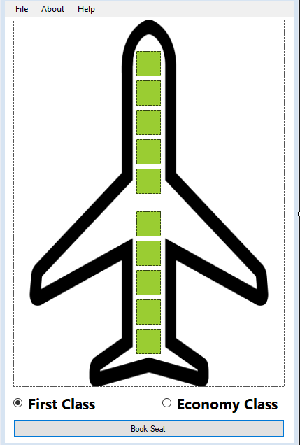

Help form:   
The help screen provides the user with simple instruction on how to use the application: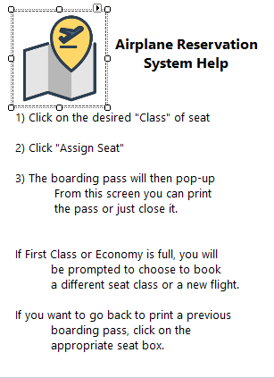

# Program Requirements and Testing

### Main Functionality:

|  |  |  |  |
| --- | --- | --- | --- |
| Completed? | Requirement | Date Completed | Date Tested |
| x | Uses one dimensional Boolean array | 4/18/18 | 4/20/18 |
| x | Has First(Seats 1-5) and Economy(Seats 6-10) classes | 4/18/18 | 4/20/18 |
| x | Provides Boarding Pass | 4/19/18 | 4/20/18 |
| x | If a class is full, offer other class | 4/18/18 | 4/20/18 |
| x | If plane is full, “Next flight leaves in 3 hours” | 4/18/18 | 4/20/18 |
| x | Cannot assigns seats previously assigned | 4/18/18 | 4/20/18 |

|  |  |  |  |
| --- | --- | --- | --- |
| Completed? | Potential Improvement | Notes | Date Completed |
| x | Available seating display | Implemented | 4/19/18 |
| x | Printable Boarding Pass | Prints boarding pass | 4/19/18 |
|  | One page application | Chose to use multiple forms for ease of use |  |

### Improvements:

# Credit

Jacob Zayak and Savion Jackson  
CPT 212 – 001 Spring 2018

Final Project: Airplane Reservation System (ARS)

